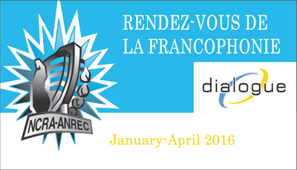

Name of producing station: CFUR Radio 88.7fm in Prince George
Name of producer: David Powe

Short bio of producer:

David was born in Moose Jaw Saskatchewan and moved province to province year by year until he landed in Ontario for high school and where he remained until he was old enough to spread his wings and travel to places larger and further away from home. He lived for some time in Whistler, BC where he found a passion for the snow and mountains. After finding his calling, he moved back to Ontario to take up a career as a student earning a diploma in Fish and Wildlife Conservation. He then decided he needed to make the trip West one more time to continue his career as a student at UNBC where he is currently taking his BA in Fish and Wildlife Mgmt.
Dave started volunteering for the radio station by jumping in on other volunteer’s radio shows and soon fell in love with the idea of having his own show. Soon after he put in his application to host the Fresh Sheet show on CFUR that highlights the newest music played from artists locally and abroad. He was fortunate enough to be hired on and continues to love it week after week. He contributes to the station in several ways, whether it’s on-air, music ripping, or writing blogs on the website, he can be found at the station most days of the week.
Short Description of the show:

This program is composed of 4 interviews grabbing the perspective of a francophone community leader, a french immersion music teacher and two UNBC students who have taken french immersion and have benefited from it in different ways. We are asking about what they love and appreciate it about the language and why they celebrate it.
Longer description of show/content:

The Show for the Rendez Vous Celebration is composed of four interviews exploring the perspectives of a francophone community leader, a french immersion music teacher and two UNBC students who have taken french immersion and have benefited from it in different ways. We are asking about what they love and appreciate it about the language and why they celebrate it.
The first interview I conducted was with Jeff, the Program Director of the Cercle des Canadiens Français de Prince George. We talked a lot about the events that are hosted and the kind of resources available to the community, he also described who he was and his passions for the language.
Next I spoke with Carmen, she is a French immersion music teacher in Prince George. She gave us a very nuanced description of her passion and my favourite part, her influences in music and her teachings that were all francophone related.
Following this discussion, we spoke with Hanna, a student here at UNBC. She works for the newspaper on campus and recently went on an exchange to France, she told us her stories and experiences in learning the language along with her passions.
Alexa was our final interviewee, and she was able to let us know what it was like to grow up without a francophone background and what it was like to not have to use the language at home but instead found her own way and reasons for loving and learning the language.

Songs played (If any):
Artist | Producer(s) | Song Name | CanCon | Length of Song | Time of Song
Danny Bell | Danny Bell | Slow Down Like You’re Supposed To | Y | 1:30 | 0:30. 26:00
 |  |  | Y/N
 |  |  | Y/N
 |  |  | Y/N
 |  |  | Y/N
 |  |  | Y/N

Format of audio:
b) A single 28 Minute "Magazine style" Spoken Word show

