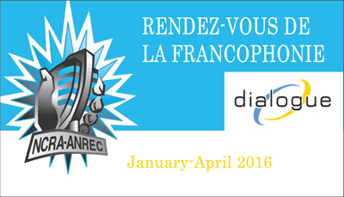

Name of producing station: Erin Radio 88.1 FM CHES
Name of producer: Phil Taylor

Short bio of producer (1 paragraph, 250 max words):

Phil Taylor has been a volunteer member of Erin Radio since 2007. Phil has been involved in the station in a variety of ways, including production of commercials and psa’s, training volunteers in production, on air, and voice tracking techniques. Phil is also a board member of Erin Radio and current music director.
1-2 Sentence description of the show:

An exploration of French immersion teaching/learning in the public schools of Erin Ontario.
Longer description of show/content (500 word max, to go on website -please provide shortened detail on each information update or audio capsule):

A half hour documentary on French immersion teaching/learning in Erin Ontario. Interviews with various stakeholders, including teachers, administrators, school board trustees, parents and students involved in the local French immersion system. Discussion of access, sustainability, methodology, and efficacy. What issues surround the delivery of French immersion in the local school board, and contrast with other school boards.

Songs played (If any):
Artist | Producer(s) | Song Name | CanCon | Length of Song | Time of Song
David Celia | David Celia | Severine | Y | 3:27 | Short excerpt
Lara Fabian | Lara Fabian | Le desamour | N | 4:36 | Short excerpt
Lara Fabian | Lara Fabian | Elle Danse | N | 3:48 | Short excerpt
Lara Fabian | Lara Fabian | Quand je ne Chante Pas | N | 3:52 | Short excerpt

Format of audio (Select one)
a) A single 28 Minute stand alone Documentary

For more information, please visit http://www.ncra.ca/rvf

