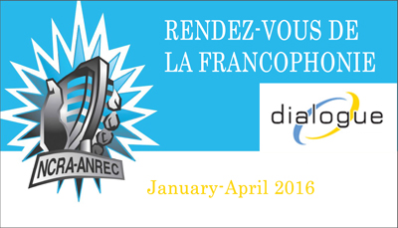

Name of producing station: CKXU 88.3 FM - Lethbridge, Alberta  
  
Name of producer: Rob Csernyik

Short bio of producer (1 paragraph, 250 max words): Rob Csernyik has been involved with community radio for almost five years across three different stations. Having lived for almost ten years in the province of Quebec, he was interested in exploring Francophone community and culture in his current home - Lethbridge, Alberta. A graduate of Bishop's University, Rob hopes to attend journalism school in fall 2016.  
  
1-2 Sentence description of the show: Magazine style spoken word show featuring conversations with three Franco-Albertan community-builders discussing questions of community and identity.

Longer description of show/content (500 word max, to go on website -please provide shortened detail on each information update or audio capsule):

Though several traditional Franco-Albertan enclaves with deep roots exist, there are many more cities and towns across the province where Francophone community and culture is created by those transplanted from other places across the globe. Lethbridge, Alberta is one of them. In this three segment magazine style spoken word show, producer Rob Csernyik interviews three Franco-Albertan community-builders who share personal stories about their involvement sharing their culture and language in an traditionally Anglophone region of Canada. This episode features conversations with community director Stéphane Rondeau (ACFA régionale de Lethbridge), radio host Rudy Desjardins (ICI Radio Canada Alberta) and French as a second language instructor Marion Trigodet (University of Lethbridge).

Songs played (If any):

|  |  |  |  |  |  |
| --- | --- | --- | --- | --- | --- |
| Artist | Producer(s) | Song Name | CanCon | Length of Song | Time of Song |
|  |  |  | Y/N |  |  |
|  |  |  | Y/N |  |  |
|  |  |  | Y/N |  |  |
|  |  |  | Y/N |  |  |
|  |  |  | Y/N |  |  |
|  |  |  | Y/N |  |  |

**Format of audio (Select one)**  
a) A single 28 Minute stand alone Documentary

b) A single 28 Minute "Magazine style" Spoken Word show  
c) 6 5Minute "Information Updates"  
d) 15 2Minute "Audio Capsules"

For more information, please visit <http://www.ncra.ca/rvf>