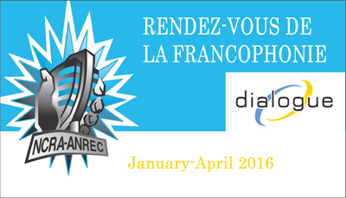

Name of producing station: CJSR FM 88.5
Name of producer: Lisa Pruden

Short bio of producer (1 paragraph, 250 max words):
Lisa Pruden has been a volunteer at CJSR for over two years, primarily for their feminist radio show Adamant Eve. She continues to enjoy learning about all things radio and spoken word, from recording to production. She also likes to spend her time with writing and crochet.
1-2 Sentence description of the show:
Les Raconteurs explores Francophone story telling in Edmonton and area.
Longer description of show/content (500 word max, to go on website -please provide shortened detail on each information update or audio capsule):
The stories we tell are special. Lisa reached out to members of the Francophone community here in Edmonton gather their stories.
First we take a listen the popular legend of The Flying Canoe/ La Chasse Gallerie. Then, Professor Lynn Penrod shares a bit about why story telling is so important to us.
Germaine Prybysh, past curator and manager of the Bonnyville & District Museum, shares stories about her father, who himself had spent some time as a lumberjack.
Members of the band Post Script (Paul Cournoyer, Steph Blais and Brayden Treble) share tales about their Francophone (or Fake-ophone!) roots.
Pierrette Requier, Edmonton’s Poet Lauriette, discusses the language of her heart, and shares a beautiful poem about skating as a young girl.

Songs played (If any):
(no songs over 1 minute included in this piece)
Artist | Producer(s) | Song Name | CanCon | Length of Song | Time of Song

Format of audio (Select one)
b) A single 28 Minute "Magazine style" Spoken Word show

For more information, please visit http://www.ncra.ca/rvf

