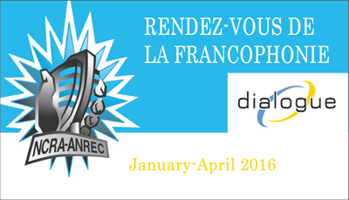

Name of producing station: CFRU
Name of producer: Sandra Doucette

Short bio of producer (1 paragraph, 250 max words): I have grown up in southern Ontario, in the french school systems. I started out in Hamilton, in a french catholique school called Monseigneur- de- Laval. When I reached high school, I went to George-P-Vanier. The only high school in Hamilton at that time. Now a days there is a high school for both the french catholic, and the French public school board. The french community has grown, and continues to grow. I now live in Fergus, Ontario. My 2 children also go to the schools of the french school board. The french elementary school in Guelph “école élémentaire L’odyssé”, and the high school in Cambridge “Père René de Galiné”. I’ve been active in the french community in Guelph and my childrens school. I’ve helped organize the Franco Fête in Guelph every June. As well as performed for the Franco Festival in Hamilton many years ago.
1-2 Sentence description of the show: show about French culture in the community of Guelph and surrounding area. French events in the community, and schools.
Longer description of show/content (500 word max, to go on website -please provide shortened detail on each information update or audio capsule): a show about French culture in the community. Its everywhere and you may not know it. You don’t have to go far for a French experience, you’ll find it close to home. There are French association in our community that arrange francophone activities and events year long. Events for all ages. As well, there are French language schools scattered all across Ontario. But you don’t have to belong to a French school to experience the francophone culture, there are events and festivals throughout the year that are for the general public. Franco Fest in Hamilton is one such Festival. It offers activities for children and adults, vendors, and arts. This past year amongst the performers were Louis-Jean Cormier, Radio Radio, Monogrenad, Cécile Dookingué, and local acro circus performers. Listen to the wonderful journey of sound from the song composite, as it takes you to another world. The band Monogrenad has that feel to their music.

Closer to Guelph is the Association Francophone de Kitchener-Waterloo. They organize events and hold club meetings for the Francophones in the community. They also organize a festival in the summer that is open to the public. There is something for every francophone or Francophile in the area. This past year marked their 10th anniversary, and they had performances all year round to celebrate. One of the performing groups was the trio Genticourm, a traditional folk group from Québèc. Let their song canot d’éccorse send you back to the time of the settlers and the fir trade.

Songs played (If any):
Artist | Producer(s) | Song Name | CanCon | Length of Song | Time of Song
monogrenad |  | composite | Y | 2 min
Genticorum |  | Canot d`eccorse | Y | 2
 |  |  | Y/N
 |  |  | Y/N
 |  |  | Y/N
 |  |  | Y/N

Format of audio (Select one)
**********b) A single 28 Minute "Magazine style" Spoken Word show******************

For more information, please visit http://www.ncra.ca/rvf

