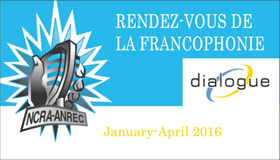

Name of producing station: Trent Radio
Name of producer: Mounira Benallou

Short bio of producer (1 paragraph, 250 max words): Mounira Benallou is a New Canadian from Paris, France who is making her first foray into Community Radio Production by participating with Trent Radio in the Rendezvous Francophonie 2016.
1-2 Sentence description of the show: A light-hearted and touching story of a New Canadian from Paris, France, who moved to Peterborough, Ontario. A wife, mother and professional, Mounira tells us about her first impressions of Peterborough, and shares some experiences from the first 3 years of her International Adventure.
Longer description of show/content (500 word max, to go on website -please provide shortened detail on each information update or audio capsule): A light-hearted and touching story of a New Canadian from Paris, France, who moved to Peterborough, Ontario for an International Experience almost 4 years ago. Mounira is married with two young children, and is a working professional with an education in engineering. She volunteers as a French Language Conversation Group facilitator at the New Canadians Centre, and this is her first experience making radio. Her approach to life is confident and joyful, and her story is heart-warming.

Songs played (If any):
Artist | Composer | Song Name | CanCon | Length of Song | Time of Song
Bolero Trio | Adam Shugar | A Single Shot Glass in the Dark | Y | 30 | 0:00
Adam Crossman | Adam Crossman | Purple Kisses | Y | 4:06  Background ON Loop | 0:34 & 12:00 & 21:25
Mylene Farmer | Mylene Farmer | C’est Une Belle Journee | N | 4:20 | 17:20
Bolero Trio | Adam Shugar | A Single Shot Glass in the Dark | Y | 20 | 27:53

Format of audio (Select one)
a) A single 28 Minute stand alone Documentary
b) A single 28 Minute "Magazine style" Spoken Word show
c) 6 5Minute "Information Updates"
d) 15 2Minute "Audio Capsules"

For more information, please visit http://www.ncra.ca/rvf

