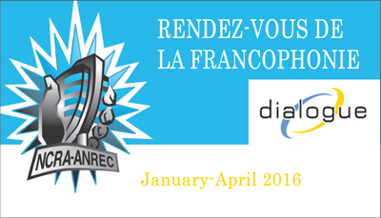

Name of producing station: CFMH
Name of producer: Abigail Smith

‘Work, Smile, Laugh’ is a meditation on the uniqueness of Francophone life in the largely English city of Saint John, New Brunswick. A city with a tiny 5% French population is home to an inspiring French school and community centre, offering services and connectivity to the city’s French community. ‘Work, Smile, Laugh’ contains music by New Brunswick band Les Hay Babies and proudly considers what the two language communities can do to live together more harmoniously.
Songs played (If any):
Artist | Producer(s) | Song Name | CanCon | Length of Song | Time of Song
Les Hay Babies |  | J’ai vendu mon char | Y | Total length is 3:11 and was played in excerpts | 1:00  27:00
Ariane Moffatt |  | De mort à vivant | Y/N | 4:27 | 21:00
 |  |  | Y/N
 |  |  | Y/N
 |  |  | Y/N
 |  |  | Y/N

Format of audio (Select one)
a) A single 28 Minute stand alone Documentary

