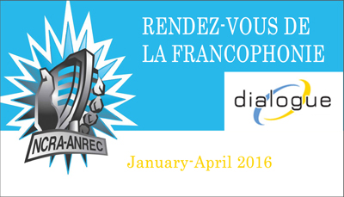

Name of producing station: CKUW 95.9 in Winnipeg  
  
Name of producer: Barney Morin

Short bio of producer (1 paragraph, 250 max words):

From Otterburne, Manitoba, Canada, Barney Morin grew up on the farm, but really only drove his dad crazy because he talked too much. Now, he's pursuing a career in broadcasting and comedy at the Univeristy of Winnipeg and Red River College through Joint-Communications program. He's such a big fan of Canada, that he hosts a weekly show called Made in Canada on CKUW 95.9 that showcases only Canadian music. When he's not checking out cool bands, he tries to escape and explore the little corners of the country, one camping trip at a time.   
  
1-2 Sentence description of the show:

*We explore what it means to be Franco-Manitoban with your guide Barney Morin.*   
  
Longer description of show/content (500 word max, to go on website -please provide shortened detail on each information update or audio capsule):

*Barney Morin will bring you into the Franco-Manitoban culture to give you a taste of how French culture has developed since the formation of the province. St Boniface is normally known as a hub of Francophones, but he'll show you where to find towns we're tradition is strong and where traditions have seen better days. This half hour adventure will also show you how the Franco-youth are keeping busy.*

Songs played (If any):

|  |  |  |  |  |  |
| --- | --- | --- | --- | --- | --- |
| Artist | Producer(s) | Song Name | CanCon | Length of Song | Time of Song |
| Justin Lacroix | Justin Lacroix | Bottes De Cowboy | Y | 3:54 | 19:50 |
| Rayannah | Rayannah | Delphine et Marilou | Y | 4:18 | 25:22 |
|  |  |  | Y/N |  |  |
|  |  |  | Y/N |  |  |
|  |  |  | Y/N |  |  |
|  |  |  | Y/N |  |  |

A single 28 Minute stand alone Documentary

For more information, please visit <http://www.ncra.ca/rvf>