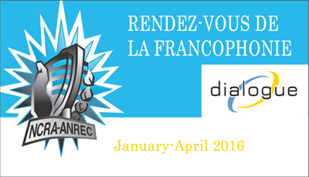

Name of producing station: CFUV 101.9 FM
Name of producer: Kluane Buser-Rivet & CILS FM

Short bio of producer (1 paragraph, 250 max words):
Kluane Buser-Rivet is a volunteer at CFUV 101.9 FM and student at Uvic, where she is studying Gender Studies and Child & Youth Care. She has previously worked and volunteered with the United Way, City of Victoria Youth Council and Sole Power Festival.
1-2 Sentence description of the show:
A radio documentary portrait of the cultural diversity of the Francophone community in Victoria, BC.
Longer description of show/content (500 word max, to go on website -please provide shortened detail on each information update or audio capsule):

Songs played (If any):
Artist |  | Song Name | CanCon | Length of Song | Time of Song
Jane Birkin |  | Elaeudanla Teïtéïa | N | Loop | 00:30
Souad Massi |  | Raoui | N | Loop | 2:30
Rachid Taha |  | Ya Raya | N | 15 sec | 4:48
Rachid Taha |  | Ya Raya | N | 23 sec | 5:15
Souad Massi |  | Raoui | N | 35 sec | 8:17
Le reve du diable |  | Le sirop d'erable | Y | 1:28 | 11:35
Baaba Maal |  | Sabaabu | N | 1:00 | 13:30
Amelie |  | La Valse D'Amelie | N | 48 sec | 14:30
Rodrigue Milien |  | Nostalgie | N | 22 sec | 19:50
Rodrigue Milien |  | Mwen Ta Renmen Konnen | N | 13 sec | 25:02
Rodrigue Milien |  | Nostalgie | n | 58 sec | 25:52
Rodrigue Milien |  | Nostalgie | n | 21 sec | 27:45
Jane Birkin |  | Elaeudanla Teïtéïa | n | Loop 38 sec | 28:07

Format of audio (Select one)
a) A single 28 Minute stand alone Documentary X
b) A single 28 Minute "Magazine style" Spoken Word show
c) 6 5Minute "Information Updates"
d) 15 2Minute "Audio Capsules"

For more information, please visit http://www.ncra.ca/rvf

