NCRA Audio Submission Form
Last Updated Jan 2016
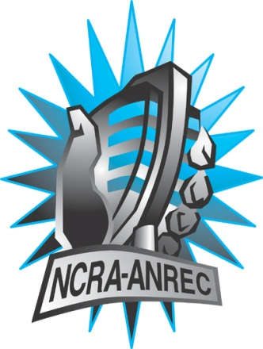
180 Metcalfe St, Suite 608
Ottawa, Ontario K2P 1P5
(613) 321-1440
www.ncra.ca

For more information on how to fill out this form, see the grant or e-mail information submitted when you agreed to the project or visit our website here: www.ncra.ca/submitting

Content may be uploaded to the ncra.ca website and its networks

Please complete and return to the best of your abilities

Most completed sheets and audio is submitted to barry@ncra.ca

Name of project/grant: RVF
Name of producing station: CHLY
Name of producer: Raymond Albert
Contact information of producer or station coordinator: 250-716-3410

Short bio of producer (1 paragraph, 250 max words): Raymond Albert is host of a metal show called Drop the Hammer on CHLY. He has also been a host, cameraman, and video editor for the local community cable tv channel. He is also a bass player in a metal/prog band.
1-2 Sentence description of the show: Interviews with francophone residents of Nanaimo.
Longer description of show/content (500 word max, to go on website -please provide shortened detail on each information update or audio capsule): Guests : Joanne Hogan, Gilles Le Patezour, Luc Begin and Chad Raill. Host Raymond Albert interviewed four Native French speakers from diverse walks of life for their thoughts about Nanaimo and multiculturalism. Specifically the talking points covered were:
- Talk to me about your Heritage?
- Talk to my about your identity?
- Talk to me about your Community?
Thoughts about:
- Render-Vous de la Francophonie
- Canada Day #150.
- The difference between St-Jean & Canada Day

Songs played (If any):
*Required for SOCAN and CRTC Logging - Add lines if needed
CRTC Cat | Artist | Composer(s) | Song Name | CanCon (Y/ N) | Length of Song | Time of Song
21 | Raymond Albert | Raymond Albert | Unnamed | y | 27:07

Are the songs above "Copyright Free", i.e. in the public domain?: Yes
Length of audio: 27:07

Other Information (If necessary):
This file replaces our previous submission. The two are identical except for the background music. There is no music other than background music throughout.

Format for Payment (If applicable): Hold for Station Credit

Name on Cheque (If applicable): Radio Malaspina Society

Location of Cheque to be sent (If applicable): #2 – 34 Victoria Cres. Nanaimo BC V9R 5B8

