NCRA Audio Submission Form
Last Updated Jan 2016
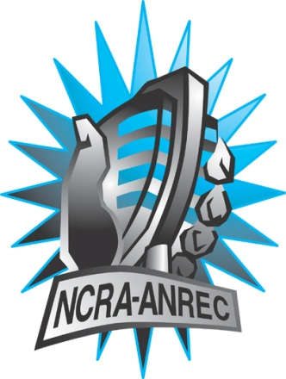
180 Metcalfe St, Suite 608
Ottawa, Ontario K2P 1P5
(613) 321-1440
www.ncra.ca

For more information on how to fill out this form, see the grant or e-mail information submitted when you agreed to the project or visit our website here: www.ncra.ca/submitting

Content may be uploaded to the ncra.ca website and its networks

Please complete and return to the best of your abilities

Most completed sheets and audio is submitted to barry@ncra.ca

Name of project/grant: Rendez-vous de la francophonie (RVF)
Name of producing station: NCRA Office
Name of producer: Patrick Auguste
Contact information of producer : patrick@ncra.ca

Short bio of producer (1 paragraph, 250 max words):
Patrick Auguste is the Project Manager of the RVF for NCRA. He has a background in management and finance and have a great experience volunteering in communities and in radio hosting at our station members CHUO-FM and CKCU- FM. He is the actual chair of Development and Peace organization for Ottawa francophone which is working in awareness, education of the general public and the decision makers in Canada and raising funds to help for better conditions of living of the people in South world countries.
1-2 Sentence description of the show:
This documentary is a covering of the event of the launch last November 2016 of the Sir Wilfrid Laurier : Builder of today's Canada project in Ottawa by the Cross Cultural Foundation of Dialogue. It presents the speeches and interviews made that day at this event by NCRA staff on site.

Longer description of show/content (500 word max, to go on website -please provide shortened detail on each information update or audio capsule):
In this first show that Patrick have produced for NCRA, he is covering the launch event of the Sir Wilfrid Laurier : Builder of today's Canada project about by the Cross Cultural Foundation of Dialogue who is one of the main parteners of NCRA for the Rendez-Vous de la Francophonie 2017. This Sir Wilfrid Laurier project from La Fondation du Dialogue des Culture is about different package of tools provided to know more about M. Wilfrid Laurier who is the first francophone Prime Minister of Canada who ran the country from office from 11 July 1896, to 6 October 1911, his life, his achievements, challenges and legacy. This 28 minutes audio documentary presents the speaches and Interviews that the host Patrick Auguste made with several key persons of the Sir Wilfrid Laurier : Builder of Today's Canada project who were at this launching event whick took place last november at the Laurier House in Canada. It is generally in english with some parts in french.
Songs played (If any):
*Required for SOCAN and CRTC Logging - Add lines if needed
CRTC Cat | Artist | Composer(s) | Song Name | CanCon (Y/ N) | Length of Song | Time of Song

Are the songs above "Copyright Free", i.e. in the public domain?:
No.
Length of audio: 28:00

