NCRA Audio Submission Form
Last Updated Jan 2016
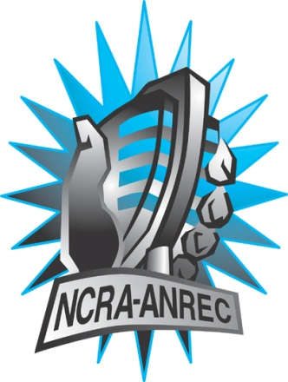
180 Metcalfe St, Suite 608
Ottawa, Ontario K2P 1P5
(613) 321-1440
www.ncra.ca

For more information on how to fill out this form, see the grant or e-mail information submitted when you agreed to the project or visit our website here: www.ncra.ca/submitting

Content may be uploaded to the ncra.ca website and its networks

Please complete and return to the best of your abilities

Most completed sheets and audio is submitted to barry@ncra.ca

Name of project/grant:
Rendez-vous de la Francophonie
Name of producing station:
Amherst Island Radio – CJAI 92.1 FM
Name of producer:
Judy Bierma & Terry McGinn
Contact information of producer or station coordinator:
judybierma@gmail.com & ttmcginn@gmail.com
Short bio of producer (1 paragraph, 250 max words):
Judy Bierma grew up on Amherst Island as “The Cheesemaker’s daughter” and has taken on that persona in her life as a radio host and local columnist. Judy has a passion for local issues, the people of Amherst Island, and their histories. Terry McGinn is a local market gardener, radio host, and professional volunteer who can’t say “no” to a good committee meeting.
1-2 Sentence description of the show:
We talk to two local residents who have lifelong connections to the French language and francophone culture, but who come from quite different backgrounds.
Longer description of show/content (500 word max, to go on website -please provide shortened detail on each information update or audio capsule):
Michele LeLay’s long career as an educator and activist has revolved around the French language and access for those who speak it. Growing up in Montreal, and moving to Ottawa before it was bilingual, Michele tells us about being at the forefront of Ontario’s foray into bilingualism. Sally Bowen of Topsy Farms joins us to relate her discovery, passion, and lifelong attachment to the French language and francophone culture, and how she brings it front and centre whenever possible in her life as a farmer on Amherst Island.
Songs played (If any):
*Required for SOCAN and CRTC Logging - Add lines if needed
CRTC Cat | Artist | Composer(s) | Song Name | CanCon (Y/ N) | Length of Song | Time of Song

Are the songs above "Copyright Free", i.e. in the public domain?:
Not applicable
Length of audio:
28:00
Other Information (If necessary):

Format for Payment (If applicable): Cheque, Paypal, Hold for Station Credit
Cheque
Name on Cheque (If applicable):
Amherst Island Radio
Location of Cheque to be sent (If applicable):
5830 Front Road, Stella, ON – K0H 2S0

