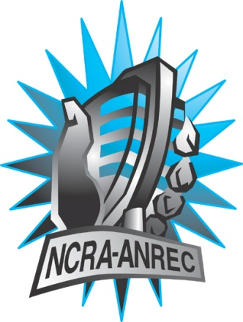
180 Metcalfe St, Suite 608
Ottawa, Ontario K2P 1P5
(613) 321-1440
www.ncra.ca

For more information on how to fill out this form, see the grant or e-mail information submitted when you agreed to the project or visit our website here: www.ncra.ca/submitting

Content may be uploaded to the ncra.ca website and its networks

Please complete and return to the best of your abilities

Most completed sheets and audio is submitted to barry@ncra.ca

NCRA Audio Submission Form
Last Updated Jan 2016

Name of project/grant: Rendez-vous de la Francophonie 2016

Name of producing station: Bay of Islands Radio (CKVB)
Name of producer: Kody Gardner, Ivan Emke

Contact information of producer or station coordinator:

Kody Gardner

E-mail: kody@boir.ca

Cell: 709-640-3267

Short bio of producer (1 paragraph, 250 max words):
Kody Gardner is technical director at Bay of Islands Radio. He is currently an Electronics Engineering Student at College of the North Atlantic in Corner Brook, NL.

Ivan Emke also volunteers at Bay of Islands Radio, and is presently Associate Professor, Social and Cultural Studies at Grenfell Campus of Memorial University in Corner Brook, NL.
1-2 Sentence description of the show:

Dr. Rainer Baehre of Memorial University talks about the French history in Newfoundland, specifically on the west coast/Port-au-Port. We also chat with Anita Best on the French influence of music in Newfoundland, discussing Newfoundland icons such as Rufus Guinchard and Emile Benoit.
Longer description of show/content (500 word max, to go on website -please provide shortened detail on each information update or audio capsule):

French/Francophone history dates back hundreds of years in the province of Newfoundland & Labrador. This radio documentary focuses on both the French history and culture in the province, specifically on the Port-au-Port Peninsula.

The first guest, Dr. Rainer Baehre, is Associate Professor of Historical Studies at Memorial University's Grenfell Campus in Corner Brook, NL. He shares his knowledge on French origins along Newfoundland's 'French Shore', and how Newfoundland and Labrador's cod fishery was a major factor in attracting French settlers from the 16th to 19th centuries.

Our second guest, Anita Best, is a musician, folkorist, and tradition bearer for Newfoundland music. Ivan Emke speaks with her from her Neddies Harbour home, where she shares her thoughts on French influence on Newfoundland's music, discussing cultural icons such as Rufus Guinchard, and Port-au-Port's Emile Benoit.

Songs played (If any):
*Required for SOCAN and CRTC Logging - Add lines if needed
CRTC Cat | Artist | Composer(s) | Song Name | CanCon (Y/ N) | Length of Song | Time of Song
32 | Emile Benoit | N/A | Meach Lake Breakdown | Y | 0:56 | 15:12
32 | Emile Benoit | N/A | Jerry’s Red Mountain Jig | Y | 0:38 | 26:36

Are the songs above "Copyright Free", i.e. in the public domain?:
Yes
Length of audio: 27:59

Other Information (If necessary):

Format for Payment (If applicable): Cheque, Paypal, Hold for Station Credit
Cheque

Name on Cheque (If applicable):
Bay of Islands Radio Inc.

Location of Cheque to be sent (If applicable):
Bay of Islands Radio
126 Georgetown Road
Corner Brook, NL
A2H 3X2

