NCRA Audio Submission Form
Last Updated Jan 2016
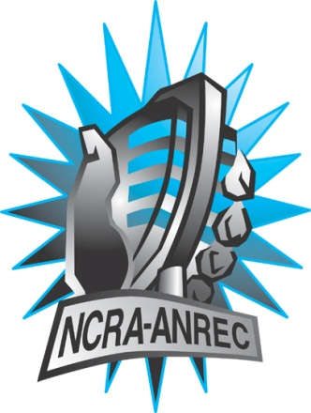
180 Metcalfe St, Suite 608
Ottawa, Ontario K2P 1P5
(613) 321-1440
www.ncra.ca

For more information on how to fill out this form, see the grant or e-mail information submitted when you agreed to the project or visit our website here: www.ncra.ca/submitting

Content may be uploaded to the ncra.ca website and its networks

Please complete and return to the best of your abilities

Most completed sheets and audio is submitted to barry@ncra.ca

Name of project/grant: Rendez-vous de la francophonie (RVF)
Name of producing station: CKTZ, Cortes Community Radio
Name of producer: Danielle Arcand
Contact information of producer or station coordinator:
Danielle Arcand: darcand888@gmail.com
Howie Roman, cortesradio@gmail.com

Short bio of producer (1 paragraph, 250 max words):
Danielle Arcand is a retired teacher and educator, now living on Cortes Island, British Columbia. After a fulfilling career spent in French language education, including more than ten years as Associate director of the Office of Francophone and Francophile Affairs at Simon Fraser University, she is still active in her retirement, volunteering as Board secretary for the national organization French for the Future and as member of the Board of directors for «Maison de la Fancophonie» in Vancouver. Danielle is keen to raise awareness about the social, historical, artistic and economical contributions made by Francophones in communities in BC and across Canada.
1-2 Sentence description of the show:
This show, Westcoast bonjour, introduces Francophones and Francophiles living on the west coast, more specifically on Cortes Island and Campbell River. Six people tell us about the circumstances that motivated them to come live on the west coast, relating struggles and successes they have had in trying to maintain French in their daily lives and featuring a musical «coup de coeur», a song chosen by each participant.
Longer description of show/content (500 word max, to go on website -please provide shortened detail on each information update or audio capsule):
As above, adding, “Although the show’s narrative is in English, the interview material quoted is in French. The narrative sums up roughly in English what is said in French so unilingual Anglophone listeners will be able to follow.”
Songs played (If any):
*Required for SOCAN and CRTC Logging - Add lines if needed

¢ | Artist | Composer(s) | Song Name | CanCon (Y/ N) | Length of Song | Time of Song
23 | Felix Leclerc | F. Leclerc | Le p’tit bonheur | Y | :40 | 4:01
21 | Harmonium | Serge Fury | Pour un instant | Y | :47 | 7:52
21 | Jann Perreau | J. Perreau | J’aime les oiseaux | Y | :54 | 13:10
23 | Gilles Vigneault | G. Vigneault | Les Gens de mon Pays | Y | 1:05 | 18:33
21 | Khaled Sound | C. Khaled | Même pas fatigué | N | :48 | 23:49
21 | Celine Dion | J.J. Goldman | Pour que tu m’aimes encore | Y | 1:16 | 26:00

Are the songs above "Copyright Free", i.e. in the public domain?: No
Length of audio: 28:02 sec

Other Information (If necessary): n/a

Format for Payment (If applicable): Cheque

Name on Cheque (If applicable): Cortes Community Radio Society

Location of Cheque to be sent (If applicable): PO Box 210, Mansons Landing, BC, V0P1K0

