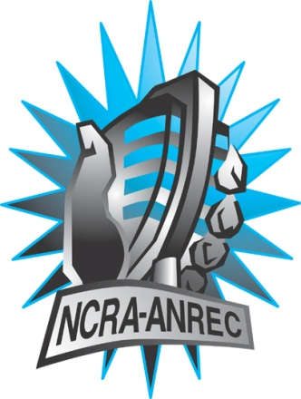
180 Metcalfe St, Suite 608
Ottawa, Ontario K2P 1P5
(613) 321-1440
www.ncra.ca

For more information on how to fill out this form, see the grant or e-mail information submitted when you agreed to the project or visit our website here: www.ncra.ca/submitting

Content may be uploaded to the ncra.ca website and its networks

Please complete and return to the best of your abilities

Most completed sheets and audio is submitted to barry@ncra.ca
Attention: BARRY ROOKE, Executive director

and PATRICK AUGUSTE, Director, French Perogramming

NCRA Audio Submission Form
Last Updated Jan 2016

Name of project/grant: RENDEZVOUS de le Francophonie

Name of producing station: Westbank and District Community Radio Society (WDCR)
Name of producer: R.J. Smith

Contact information of producer or station coordinator: R.J. Smith/General Manager/Producer

Short bio of producer (1 paragraph, 250 max words): R.J. SMITH is a veteran broadcaster and broadcast journalist with more than 34 years in the radio and television business. A broadcasting graduate of Columbia Academy and B.C.I.T., R.J's career has taken him to radio , t.v., and the newspaper business, in four Canadian time zones. He Is founder and President/GM of Westbank Community Radio Society, the Okanagan's first not for profit radio station that has accumulated more than 92,000 total listeners since 2013. For five years, R.J. Smith volunteered at prominent campus/community stations, such as CITR Vancouver, CFUV Victoria and CKDU Halifax, both in management and on air roles. Visit www.wdcr.ca
1-2 Sentence description of the show:

The show is called Soleil de L'Okanagan, featuring guest interviews with newsmakers here in the Central Okanagan and beyond. Nicole Leblanc is with the Okanagan French Cultural Centre, promoters of Maplefest Kelowna, and Jean Francois Packwood is Director-General with the Conseil Culturel et Artistique Francophone de la Columbie Brittanique (CCAFCB).
Longer description of show/content (500 word max, to go on website -please provide shortened detail on each information update or audio capsule):
Now in its 39th year of operation, the Centre Culturel Francophone de L'Okanagan is the host of the largest outdoor French festival in the Interior of British Columbia (MAPLEFEST). Executive assistant NICOLE LEBLANC talks about this year's edition and about the francophone culture here in the Okanagan and the role of the Okanagan French Cultural Centre over the past four decades. Jean Francois Packwood discusses his ongoing promotion of between 300 to 400 French musicians, singers, and artists, located throughout the Province of B.C. , including here in the Okanagan region of B.C.

Songs played (If any):
*Required for SOCAN and CRTC Logging - Add lines if needed
CRTC Cat | Artist | Composer(s) | Song Name | CanCon (Y/ N) | Length of Song | Time of Song
3 | Jocelyn Pettit | Petit | Lights on the Horizon | Y | 1m30s | 12:00:00 AM
2` | Ginette Reno | J. Worth/Les Hagan | Beautiful Second Hand Man | Y | 2m49 s | 04:18:00 PM

Are the songs above "Copyright Free", i.e. in the public domain?:
Yes.

Length of audio:
27m 59s.

Other Information (If necessary):
320 kps.

Format for Payment (If applicable): Cheque, Paypal, Hold for Station Credit
Please issue us a check for $ 1500.00, as previously discussed with Patrick. According to Patrick, checks have already been disbursed for $ 1500.00 to other NCRA members. Please send via Purolator Courier overnight shipping, WDCR will pay for the shipping. Bill to account number 5479066 (WESTBANK COMM RADIO).
Name on Cheque (If applicable): Westbank and District Community Radio Society

Location of Cheque to be sent (If applicable): WDCR Society, Basement, 3496 Creekview Crescent, West Kelowna, B.C. V4T 3C5 Please ship check to us as soon as possible.

