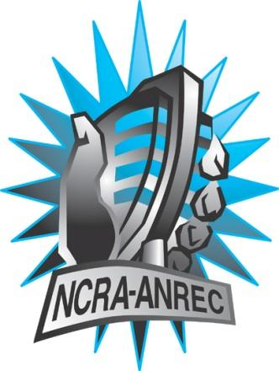  180 Metcalfe St, Suite 608  Ottawa, Ontario K2P 1P5  (613) 321-1440  www.ncra.ca  For more information on how to fill out this form, see the grant or e-mail information submitted when you agreed to the project or visit our website here: www.ncra.ca/submitting  Content may be uploaded to the ncra.ca website and its networks  Please complete and return to the best of your abilities  Most completed sheets and audio is submitted to barry@ncra.ca | NCRA Audio Submission Form  Last Updated Jan 2016  Name of project/grant: Bienvenue à Toronto  Name of producing station: CJRU 1280 AM  Name of producer: Jacob Dubé  Contact information of producer or station coordinator: elissa@cjru.ca  Short bio of producer (1 paragraph, 250 max words):  Jacob Dubé has been programming at CJRU since the spring of 2015 and co-hosts a weekly program Radio Free Krypton. He is a current news editor at The Eyeopener and was the editor-in-chief of the Canadian online arts magazine CanCulture. He’s a Franco-Ontarian and fluent Francophone with a great interest in French issues within the province, especially related to culture and education.  1-2 Sentence description of the show:  Toronto is widely considered to be one of the most multicultural cities in Canada and even North America. This documentary looks into why french speaking new Canadians are moving to Toronto, how they integrate and make it feel like home.  Longer description of show/content  Toronto is widely considered to be one of the most multicultural cities in Canada and even North America. You can’t go a couple blocks without passing by a new and different cultural neighbourhood and the city is all the better for it. But an important important piece of Canada’s cultural history seems to be missing: Francophone communities. Many Torontonians wouldn’t know that they are here. However immigration is giving a new life and meaning to french communities in this city. This documentary looks into why french speaking new Canadians are moving to Toronto, how they integrate and make it feel like home.  Songs played (If any):  *Required for SOCAN and CRTC Logging - Add lines if needed  Are the songs above "Copyright Free", i.e. in the public domain?: Gorowski - Yes. Nhapitapi - No (but we have permission to use from the organizers and the musicians)  Length of audio: 28:00  Other Information (If necessary):  Format for Payment (If applicable): Cheque  Name on Cheque (If applicable): Radio Ryerson Inc.  Location of Cheque to be sent (If applicable): 201 - 55 Gould Street Toronto, ON M5B 1E9
  CRTC Cat | Artist | Composer(s) | Song Name | CanCon (Y/ N) | Length of Song | Time of Song
  41 | Gorowski |  | Freedom Planet Orchestra | N | 0:18 | 0:46
  41 | Gorowski |  | Freedom Planet Orchestra | N | 0:12 | 7:58
  41 | Gorowski |  | Freedom Planet Orchestra | N | 0:12 | 13:46
  41 | Nhapitapi |  |  | Y | 0:10 | 22:42
  41 | Gorowski |  | Freedom Planet Orchestra | N | 0:06 | 26:39

