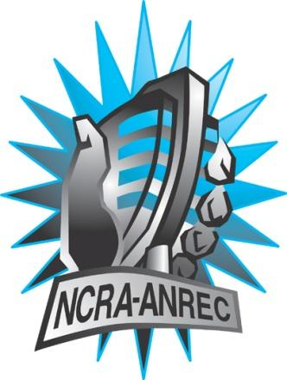
180 Metcalfe St, Suite 608
Ottawa, Ontario K2P 1P5
(613) 321-1440
www.ncra.ca

For more information on how to fill out this form, see the grant or e-mail information submitted when you agreed to the project or visit our website here: www.ncra.ca/submitting

Content may be uploaded to the ncra.ca website and its networks

Please complete and return to the best of your abilities

Most completed sheets and audio is submitted to barry@ncra.ca
NCRA Audio Submission Form
Last Updated Jan 2016

Name of project/grant:
Rendez-Vous de la Francophonie 2016-2017
Name of producing station: CFUR FM
Name of producer: Andrew Soltis
Contact information of producer or station coordinator:
Producer: soltis@unbc.ca
Station Coordinator: programming@cfur.ca

Short bio of producer (1 paragraph, 250 max words):
Andrew John Soltis is a UNBC alumni as well as CFU Radio host. He has a Bachelor of Arts degree from UNBC. He is a member of the Metis Nation. To read more about Andrew John Soltis you can visit his personal website www.pouvoirpress.com .
1-2 Sentence description of the show: A documentary on the presence of French language in relation to Metis culture in the community of Prince George BC.
Longer description of show/content (500 word max, to go on website -please provide shortened detail on each information update or audio capsule):

Andrew John Soltis takes an in depth look at his own heritage and delves into the characters and voices peppered throughout his community of Prince George, BC. Speaking to both Metis elders and millennials alike, the presence of French language has a complex history in all our narratives. During discussions with professors at the University of Northern British Columbia Andrew discovers that the French language has existed in this storied territory for longer than he ever could have realized.
This textured journey through the region's identity attempts to answer what it means to be French, and Metis.
Songs played (If any):
*Required for SOCAN and CRTC Logging - Add lines if needed
CRTC Cat | Artist | Composer(s) | Song Name | CanCon (Y/ N) | Length of Song | Time of Song
 | David Amran, Peter Rowan, James Preston | David Amran, Peter Rowan, James Preston | Red River Valley Variations | Y | 3:50 | 4:55
 | Metis Nation Music | N/A | Red River Jig | Y | 3:38 | 24:55

Are the songs above "Copyright Free", i.e. in the public domain?: Yes
Length of audio: 28:02

Other Information (If necessary):

Format for Payment (If applicable): Cheque

Name on Cheque (If applicable): CFUR Radio Society

Location of Cheque to be sent (If applicable):
CFUR Radio Society
Office 6-354
3333 University Way
Prince George BC
V2N 4Z9

