NCRA Audio Submission Form
Last Updated Jan 2016
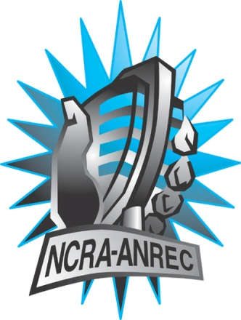
180 Metcalfe St, Suite 608
Ottawa, Ontario K2P 1P5
(613) 321-1440
www.ncra.ca

For more information on how to fill out this form, see the grant or e-mail information submitted when you agreed to the project or visit our website here: www.ncra.ca/submitting

Content may be uploaded to the ncra.ca website and its networks

Please complete and return to the best of your abilities

Most completed sheets and audio is submitted to barry@ncra.ca

Name of project/grant: Rendez-vous de la francophonie
Name of producing station: CKUW
Name of producer: Barney Morin
Contact information of producer or station coordinator: Rob Schmidt : Manager@ckuw.com

Short bio of producer (1 paragraph, 250 max words):
Metis Franco-Manitoban Barney Morin is studying Rhetoric and Communication in a joint program with Red River College and the University of Winnipeg. He has a knack for looking on the brighter side of things, while still delivering effective messages. He hosts a weekly music show on CKUW 95.9 FM entitled “Made in Canada”. Every Monday at 4 he delivers a weekly dose of Canadian music with interviews and features.
1-2 Sentence description of the show: Let host Barney Morin tour you around St Boniface in Winnipeg, Manitoba, home a vibrant Franco-phone community. Settle in for a frank and honest discussion about the state of francophonie in both French and English.
Longer description of show/content (500 word max, to go on website -please provide shortened detail on each information update or audio capsule):

Let host Barney Morin tour you around St Boniface in Winnipeg, Manitoba, home a vibrant Franco-phone community. Settle in for a frank and honest discussion about the state of francophonie in both French and English.
Songs played (If any):
*Required for SOCAN and CRTC Logging - Add lines if needed
CRTC Cat | Artist | Composer(s) | Song Name | CanCon (Y/ N) | Length of Song | Time of Song
 | Daniel Peloquin hopfner | Daniel Peloquin hopfner | Qu’allons nous faire | y | 40 secs | 3 : 15 secs
 | Jeremie and the delicious hounds | Jeremie and the delicious hounds |  | y | 36 secs | 20 : 50 sec

Are the songs above "Copyright Free", i.e. in the public domain?:
No.
Length of audio: 28:00

Other Information (If necessary):

Format for Payment (If applicable): Cheque,

Name on Cheque (If applicable): Darrel Morin…. It’s my real name.

Location of Cheque to be sent (If applicable ”A” 165 Dumoulin, R2H 0E2 Winnipeg Manitoba

