NCRA Audio Submission Form
Last Updated Jan 2016
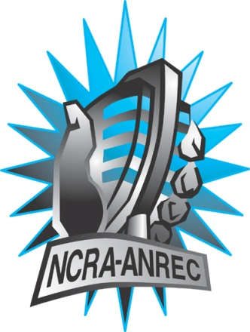
180 Metcalfe St, Suite 608
Ottawa, Ontario K2P 1P5
(613) 321-1440
www.ncra.ca

For more information on how to fill out this form, see the grant or e-mail information submitted when you agreed to the project or visit our website here: www.ncra.ca/submitting

Content may be uploaded to the ncra.ca website and its networks

Please complete and return to the best of your abilities

Most completed sheets and audio is submitted to barry@ncra.ca

Name of project/grant:
RVF 2017
Name of producing station:
Co-op Radio – CFRO 100.5 FM
Name of producer:
Laurence Gatinel
Contact information of producer or station coordinator:
Leela Chinniah – Director of Programming Administration
programs@coopradio.org – (604) 684-8494 ext. 226

Short bio of producer (1 paragraph, 250 max words):
Laurence Gatinel is a transmedia project manager involved with various community media in Vancouver, both in English and in French, her maternal language. She aims to promote the diverse francophone communities of BC.
1-2 Sentence description of the show:
The francophone artistic community is vibrant in British-Columbia. However, when it comes to financing some projects, help from Quebec or federal funders is still needed.
Longer description of show/content (500 word max, to go on website -please provide shortened detail on each information update or audio capsule):

The Conseil culturel et artistique francophone de la Colombie-Britannique (CCAFCB) lists, at all time, around 300 francophone artists and organizations. While vibrant, the francophone artistic community still requires help from Quebec or federal funders when it comes to financing projects. What can be done to better promote francophone initiatives?
Songs played (If any):
*Required for SOCAN and CRTC Logging - Add lines if needed
CRTC Cat | Artist | Composer(s) | Song Name | CanCon (Y/ N) | Length of Song | Time of Song

Are the songs above "Copyright Free", i.e. in the public domain?:
Length of audio:
28:00

Other Information (If necessary):

Format for Payment (If applicable): Cheque

Name on Cheque (If applicable): Vancouver Co-op Radio

Location of Cheque to be sent (If applicable): 2014 Wall St., Vancouver, BC, V5L 1B1

