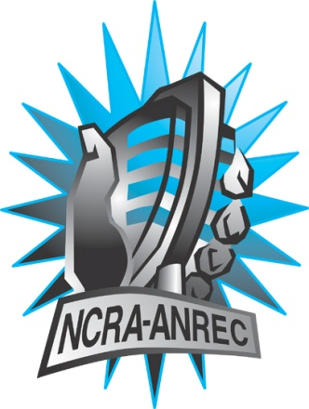
180 Metcalfe St, Suite 608
Ottawa, Ontario K2P 1P5
(613) 321-1440
www.ncra.ca

For more information on how to fill out this form, see the grant or e-mail information submitted when you agreed to the project or visit our website here: www.ncra.ca/submitting

Content may be uploaded to the ncra.ca website and its networks

Please complete and return to the best of your abilities

Most completed sheets and audio is submitted to barry@ncra.ca

NCRA Audio Submission Form
Last Updated Jan 2016

Name of project/grant: Rendez Vous de la Francophonie

Name of producing station: CKUT
Name of producer: Julia Dyck

Contact information of producer or station coordinator: funding@ckut.ca

Short bio of producer (1 paragraph, 250 max words):
Julia Dyck is multidisciplinary artist and producer from Winnipeg, currently based in Montreal. She is interested in the intersections of identity, language, voice and gender, and explores this through the production of radio art, experimental music and performance. She is one of the current hosts of the XX Files on CKUT 90.3FM.

1-2 Sentence description of the show:
Montreal has a certain je ne sais quoi, especially when it comes to communication. From Bill-101 to the lyrics of local music groups, to restaurant menus and intercultural romance, this documentary explores the complexity and evolution of human communication in Montreal. We borrow from each other and jouer avec les mots. Some call it franglais, but it’s Montréalais.
Longer description of show/content (500 word max, to go on website -please provide shortened detail on each information update or audio capsule):

Montreal has a certain je ne sais quoi, especially when it comes to communication. From Bill-101 to the lyrics of local music groups, to restaurant menus and intercultural romance, this documentary explores the complexity and evolution of human communication in Montreal. We borrow from each other and jouer avec les mots. Some call it franglais, but it’s Montréalais.

Participants:

Aimee Wall
Anne Farkas
Belen Rebecca Arenas
Hélène Barbier and Ben Lalonde of the band PHERN
Amanda Harvey

Songs played (If any):
*Required for SOCAN and CRTC Logging - Add lines if needed
CRTC Cat | Artist | Composer(s) | Song Name | CanCon (Y/ N) | Length of Song | Time of Song
2 | Phern | Phern | Samantha | Y | 1:40 | 18:38

Are the songs above "Copyright Free", i.e. in the public domain?: no
Length of audio: 28:14

Other Information (If necessary):

Format for Payment (If applicable): Cheque

Name on Cheque (If applicable): “Julia Dyck” (producer), “CKUT Radio” (station)

Location of Cheque to be sent (If applicable):
3647 University
Montreal QC
H3A 2B3

