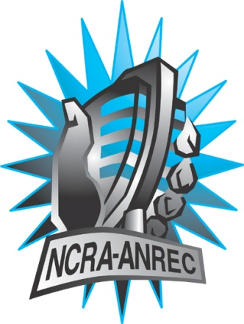
180 Metcalfe St, Suite 608
Ottawa, Ontario K2P 1P5
(613) 321-1440
www.ncra.ca

For more information on how to fill out this form, see the grant or e-mail information submitted when you agreed to the project or visit our website here: www.ncra.ca/submitting

Content may be uploaded to the ncra.ca website and its networks

Please complete and return to the best of your abilities

Most completed sheets and audio is submitted to barry@ncra.ca

NCRA Audio Submission Form
Last Updated Jan 2016

Name of project/grant:

RVF
Name of producing station:
CFBX-FM
Name of producer:

Sebastien Plante & Luke Smith
Contact information of producer or station coordinator:

nlsmithconsulting@gmail.com

Short bio of producer (1 paragraph, 250 max words):
The CanQueer team have over a decade of community radio experience and bring together the most syndicated Canadian LGBT+ Community talk show.

1-2 Sentence description of the show:
The CanQueer team interviews the University of Ottawa researcher Dr. Alexandre Baril. Dr Baril’s research into the under-representation of trans persons in faculty members in Canadian Universities, with a specific focus on the barriers contributing to the exclusion of trans people in the francophone university community.

Longer description of show/content (500 word max, to go on website -please provide shortened detail on each information update or audio capsule):

The CanQueer team interviews the University of Ottawa researcher Dr. Alexandre Baril. Dr Baril’s research into the under-representation of trans persons in faculty members in Canadian Universities, with a specific focus on the barriers contributing to the exclusion of trans people in the francophone university community. We will explore if the exclusion of trans professors contributes to the exclusion of trans students in Canada’s francophone universities.

Songs played (If any):
*Required for SOCAN and CRTC Logging - Add lines if needed
CRTC Cat | Artist | Composer(s) | Song Name | CanCon (Y/ N) | Length of Song | Time of Song

Are the songs above "Copyright Free", i.e. in the public domain?:
na
Length of audio:
28 Min
Other Information (If necessary):

